Project Submission

Udagram Image Filtering Microservice

1. Link to Github Repo: [MbuaNkeng/image-filter-project: Project 2 for the ALT udagram project for AWS (github.com)](https://github.com/MbuaNkeng/image-filter-project)
2. Elastic Beanstalk after Deployment

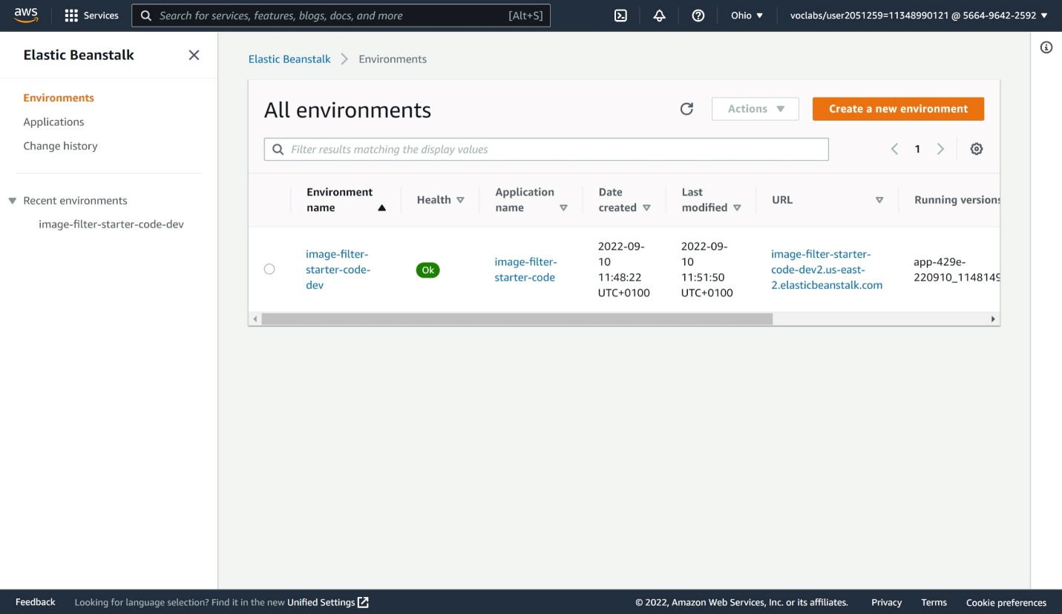

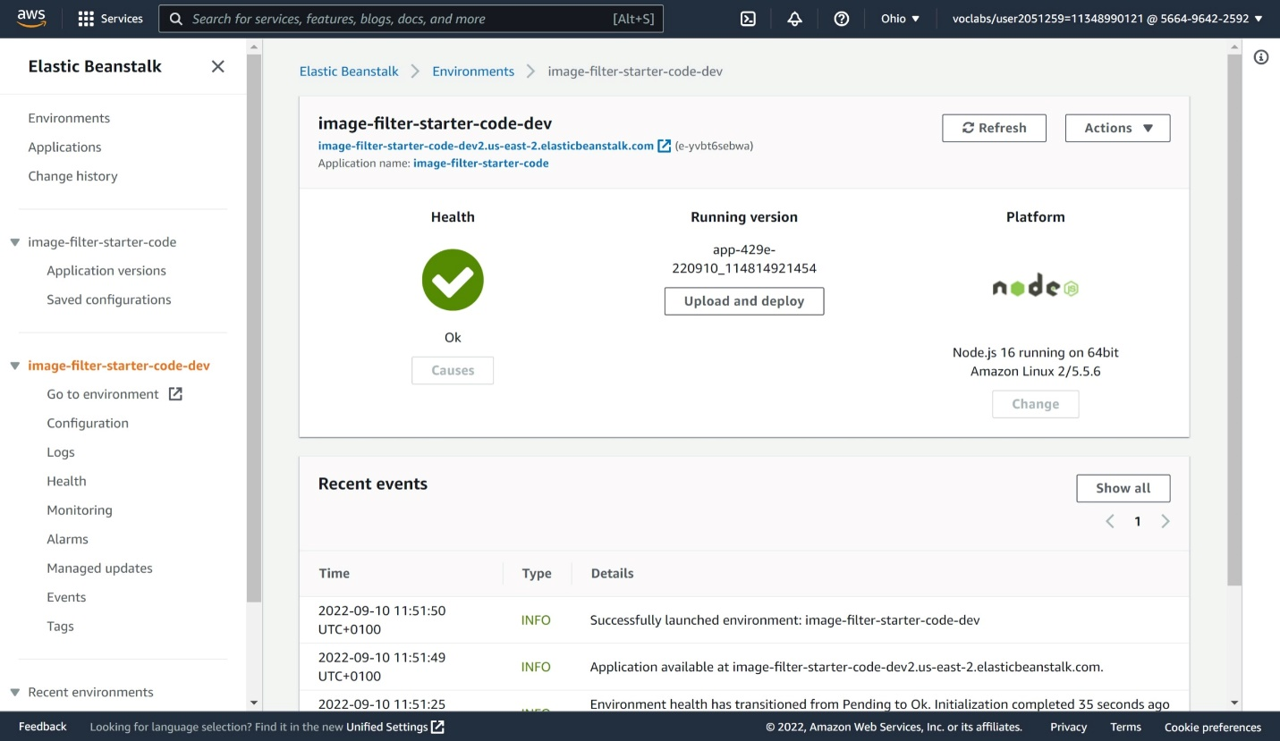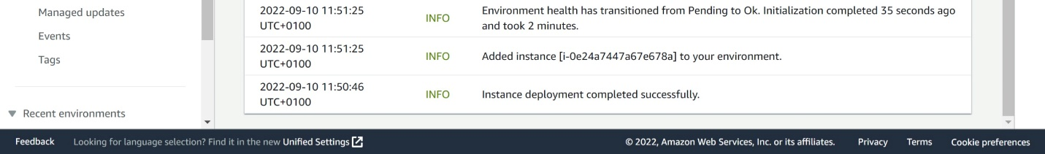

1. Endpoint URL: <http://image-filter-starter-code-dev2.us-east-2.elasticbeanstalk.com/filteredimage?image_url=”Test> any Image URL here”

My Test Sample In Postman: <http://image-filter-starter-code-dev2.us-east-2.elasticbeanstalk.com/filteredimage?image_url=https://img-s-msn-com.akamaized.net/tenant/amp/entityid/AA11FGVu.img?w=1224&h=608&q=90&m=6&f=jpg&u=t>